Khangai Herds- winter racing
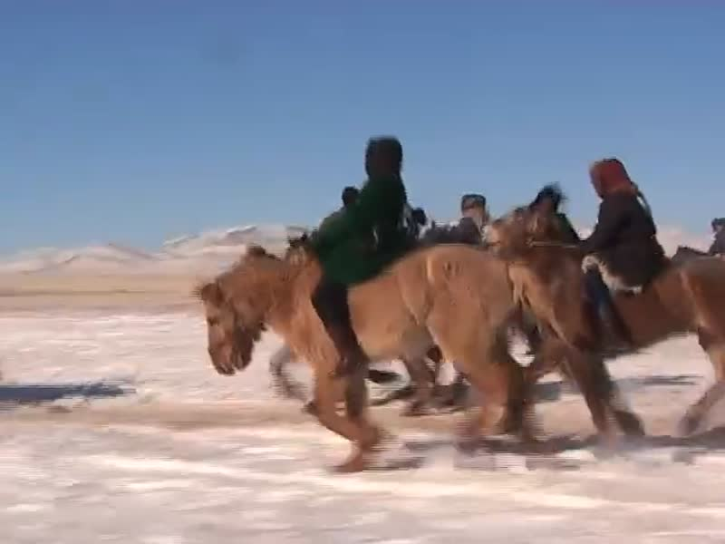

identifier
ea6a521f-ed63-446b-beb1-3728c654a0dd

creator
Fijn, Natasha

type
Moving Image

coverage
Mongolia

description
Near the capital of Ulaanbaatar in Mongolia, horses and jockeys race in winter temperatures of more than minus 30 degrees Celcius. The child jockeys often have blemishes on their cheeks from frost bite. Horse racing is highly prestigious in Mongolia and is usually held throughout the countryside during the warm and bountiful summer. Winter racing, however, is very different in such harsh and unforgiving conditions.

publisher

source
<https://vimeo.com/14327917>

rights
<https://creativecommons.org/licenses/by-nc-nd/3.0/>

subject
Khangai Herds
Living with Herds
Naadam
domestic animal
ethnography
horse
horseracing
human-animal
jockeys
observational film
winter

date
2010-08-21

language
Mongolian

format
video/mp4

contributor

original filename
Khangai Herds- winter racing.mp4

remote embed url
https://player.vimeo.com/video/14327917

relation

extent
41.9MiB
492.586667

